UNIT V – Advanced Machine Learning, Neural Systems & Applications
12 hrs (CT:10 hrs, SL:2 hrs)
Regression and classification, regularization, bias-variance tradeoff and cross-validation; KNN and KD-trees; clustering with K-Means++; reinforcement learning and Q-learning; biological and artificial neurons; perceptron, MLP and backpropagation; deep learning basics; NLP, transformers, computer vision, CNNs, robotics, SLAM, self-driving cars, enterprise AI, digital twins, smart homes and IoT-integrated AI.

1. Step 1 – Identify the problem type
There are four major types of machine learning problems.
Problem type | Purpose | Example
Regression | Predict a continuous numerical value | House price prediction
Classification | Predict a category or class | Spam or Not Spam
Clustering | Group similar data points | Customer segmentation
Reinforcement Learning | Learn through rewards and penalties | Game-playing robot
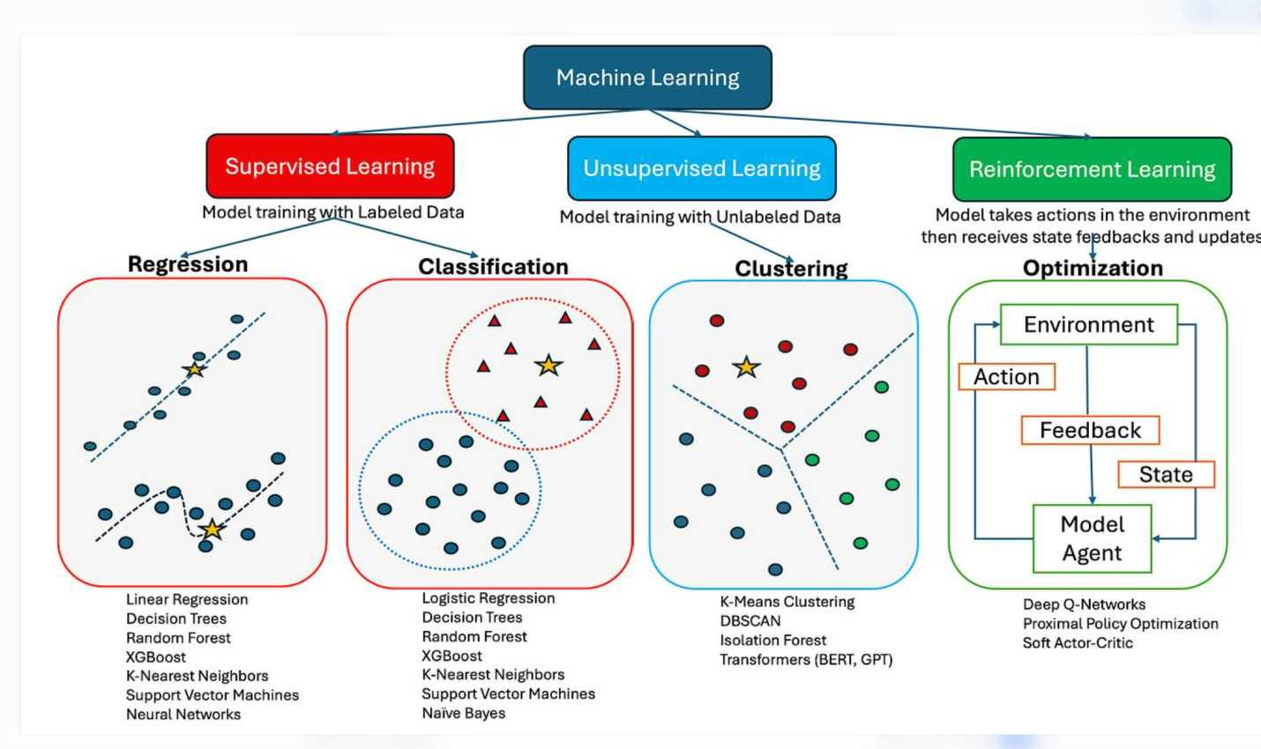

2. Step 2 – Select the algorithm based on the problem
Problem | Suitable algorithms
Regression | Linear Regression, Decision Tree Regressor , Random Forest Regressor
Classification | Logistic Regression, KNN, Decision Tree, Random Forest, SVM, Naive Bayes
Clustering | K-Means, DBSCAN, Hierarchical Clustering
Reinforcement Learning | Q-Learning, SARSA, Deep Q-Network

3. Step 3 – Understand with a practical example
Let's consider a Student Pass/Fail Prediction problem.
Problem statement: Predict whether a student will pass or fail based on study hours and attendance.
Sample dataset:
Study Hours | Attendance (%) | Result
2 | 40 | Fail
3 | 50 | Fail
5 | 65 | Pass
6 | 75 | Pass
8 | 90 | Pass
1 | 30 | Fail
Step A: Identify the input and output
- Input features (X): Study Hours, Attendance.
- Target variable (Y): Result.
- Output classes: Pass or Fail.
Step B: Identify the problem
The output contains categories (Pass/Fail).
Therefore, this is a Classification problem.
Step C: Select candidate models
We can try:
- Logistic Regression
- Decision Tree Classifier
- K-Nearest Neighbors (KNN)
- Random Forest Classifier
Step D: Train and evaluate the models
We train all four algorithms using the same training and testing datasets.
Example evaluation results (illustrative):
Model | Accuracy
Logistic Regression | 85%
Decision Tree | 90%
KNN | 80%
Random Forest | 95%
Illustrative results only, not actual experimental measurements.
Step E: Select the best model
In this example, Random Forest has the highest accuracy (95%).
Therefore, we can select Random Forest, after also checking precision, recall, F1-score and cross-validation results.
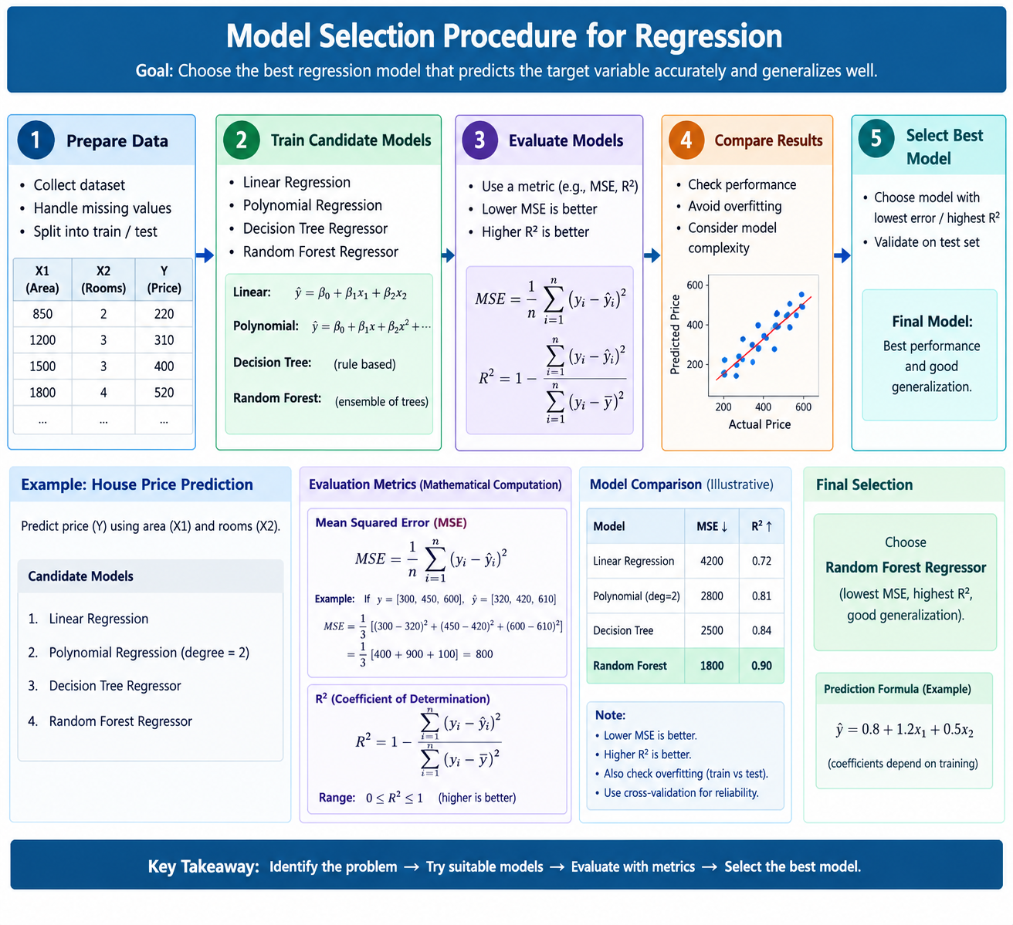

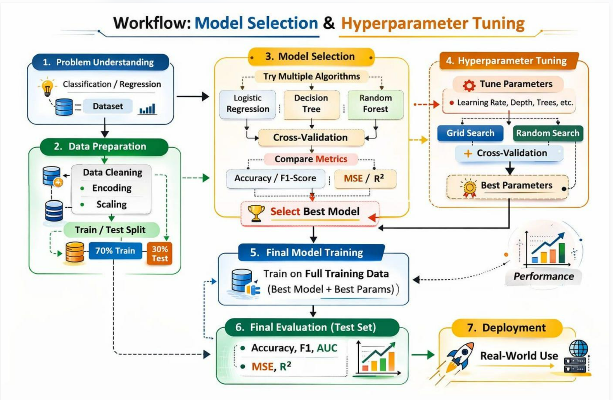
Step | Activity | Purpose
1 | Define problem | Understand what to predict
2 | Collect dataset | Obtain relevant data
3 | Identify target | Determine output variable
4 | Select algorithms | Choose suitable candidate models
5 | Split dataset | Training and testing
6 | Train models | Learn patterns
7 | Evaluate models | Compare performance
8 | Select model | Choose the most suitable mode

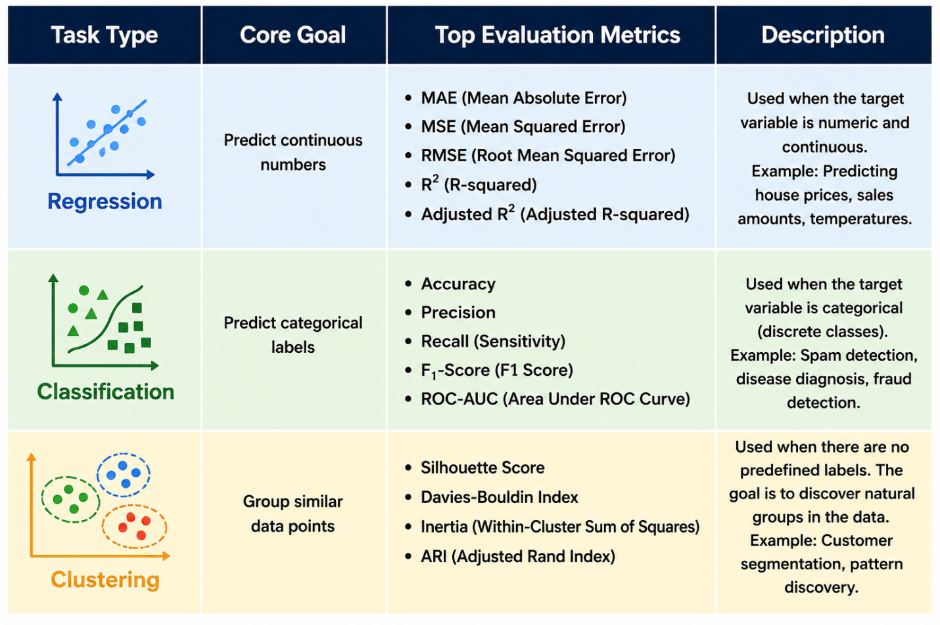

1. Regression Metrics
Metric | Explanation
MAE | Measures the average absolute difference between actual and predicted values. Lower is better.
MSE | Calculates the average of squared prediction errors. It penalizes large errors more heavily. Lower is better.
RMSE | Square root of MSE; measures prediction error in the original unit of the target variable. Lower is better.
R² (R-squared) | Measures how much variation in the target variable is explained by the model. Higher is generally better.
Adjusted R² | Measures explained variation while considering the number of input features. It penalizes unnecessary features. Higher is generally better.

2. Classification Metrics
Metric | Explanation
Accuracy | Percentage of total predictions that are correct. Higher is better.
Precision | Out of all predicted positive cases, measures how many are actually positive. Higher is better.
Recall (Sensitivity) | Out of all actual positive cases, measures how many the model correctly identifies. Higher is better.
F1-Score | Harmonic mean of Precision and Recall; balances both metrics. Higher is better.
ROC-AUC | Measures how well a model distinguishes between positive and negative classes across different thresholds. Higher is better.

3. Clustering Metrics
Metric | Explanation
Silhouette Score | Measures how closely data points fit within their own cluster compared with other clusters. Higher (closer to +1) is better.
Davies-Bouldin Index (DBI) | Measures similarity between clusters based on their spread and separation. Lower is better.
Inertia | Measures the sum of squared distances between data points and their cluster centroids. Lower indicates tighter clusters.
ARI (Adjusted Rand Index) | Measures how closely predicted clusters match known actual groups, adjusted for chance. Higher is better.
Easy way to remember:
- Regression: How far are the predictions from actual values?
- Classification: How correctly does the model identify categories?
- Clustering: How well are similar data points grouped together?

Part 1: Questions – Machine Learning Model Selection
1. If we want to predict house prices based on area, location, and number of rooms, which type of machine learning problem should we use?
2. If we want to predict whether an email is spam or not spam, which type of machine learning problem should we use?
3. If we want to group customers based on their purchasing behaviour without predefined labels, which machine learning technique should we use?
4. If we want to train a computer to play chess using rewards and penalties, which machine learning approach should we use?
5. If Logistic Regression gives 85% accuracy and Random Forest gives 95% accuracy, should we always select Random Forest? Why?

Part 2: Answers
1. Regression: House price is a continuous numerical value. Linear Regression or Random Forest Regressor can be used.
2. Classification: The output has two categories: Spam and Not Spam. Logistic Regression, Naive Bayes, or Random Forest can be used.
3. Clustering: K-Means, DBSCAN, or Hierarchical Clustering can group customers based on similarities.
4. Reinforcement Learning: The computer learns through rewards and penalties. Q-Learning is one suitable algorithm.
5. No. We should not select a model based only on accuracy. We must also compare:
- Precision
- Recall
- F1-score
- Cross-validation performance
- Overfitting
- Computational cost

Regularization
Concept
- Regularization prevents overfitting.
- It adds a penalty to the model's loss function.
- Helps control model complexity.
Types
L1 Regularization (Lasso) | L2 Regularization (Ridge)
Can reduce coefficients to zero | Shrinks coefficients towards zero
Performs feature selection | Controls large coefficients
Sparse models | More stable coefficients

Practical example
Suppose a house price model uses 20 features, but some features are unnecessary.
- Without regularization: Model may overfit.
- With L1: Some feature coefficients become zero.
- With L2: Large coefficients are reduced.
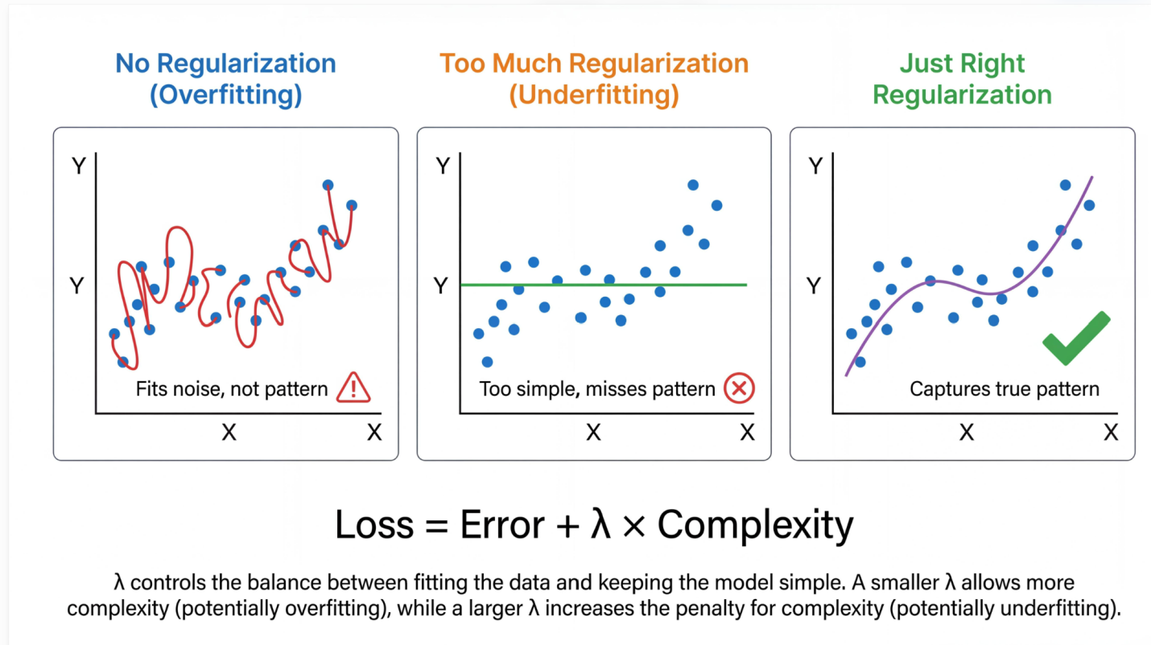
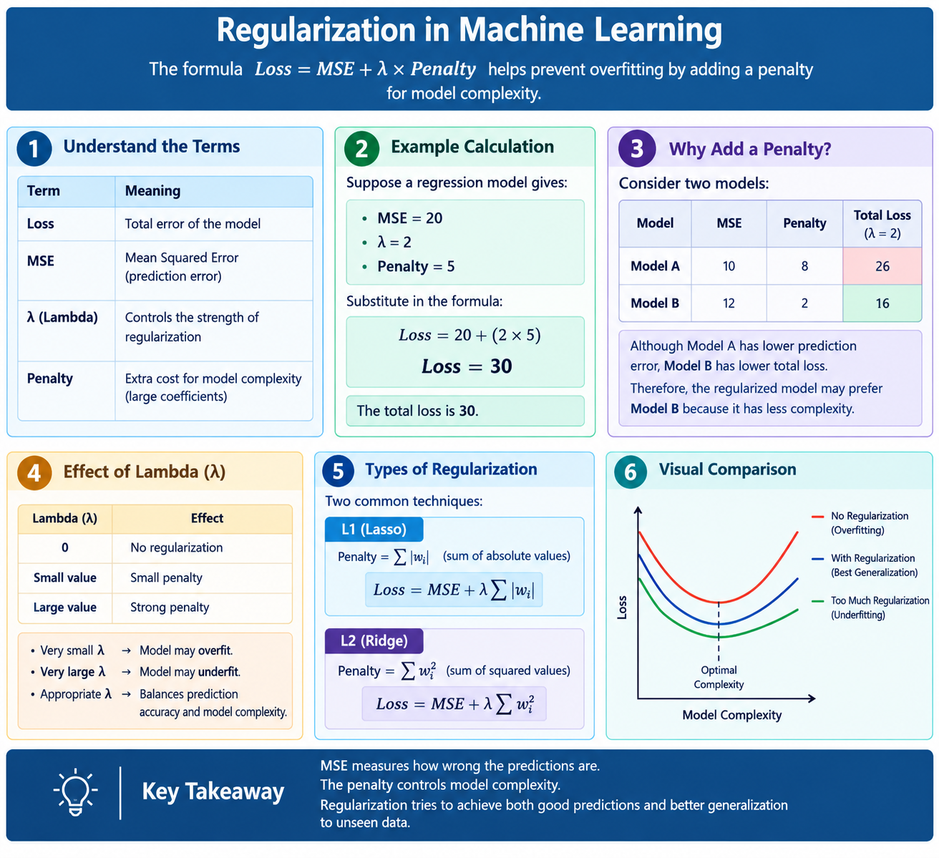

Topic 3: Bias-Variance Tradeoff and Cross-Validation
Bias-Variance Tradeoff
- Bias: Error caused by overly simple model assumptions.
- Variance: Error caused by excessive sensitivity to training data.
- Goal: Balance bias and variance for better generalization.
High Bias | High Variance
Underfitting | Overfitting
Model too simple | Model too complex
Poor training performance | Good training, poor testing performance

Cross-Validation
K-Fold Cross-Validation:
- Divide dataset into K equal folds.
- Train using K-1 folds.
- Test using the remaining fold.
- Repeat K times.
- Calculate average performance.

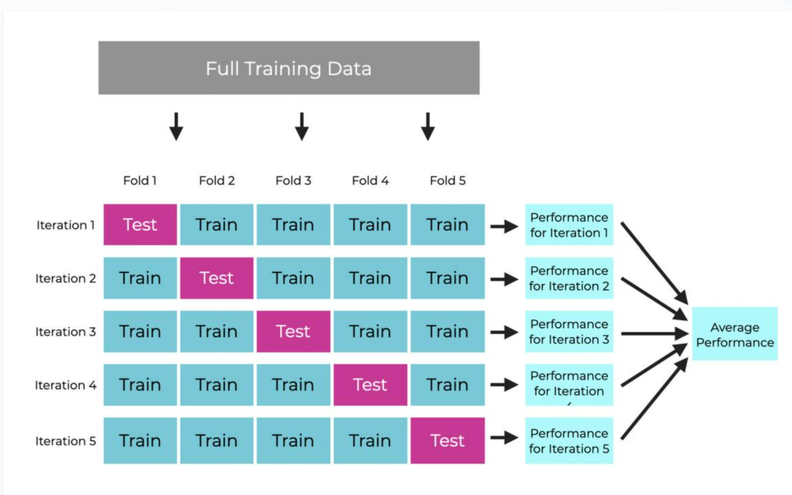

For 5-fold cross-validation:
- Dataset divided into 5 parts.
- Each part is used once for validation.
- Final model performance is the average of 5 validation scores.
K-Nearest Neighbors (KNN)
- KNN is a supervised learning algorithm.
- Predicts based on the nearest K data points.
- Uses distance measurements.
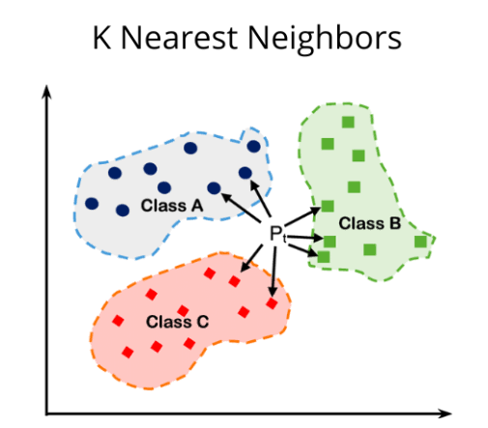

KD-Trees
- KD-Tree means K-Dimensional Tree.
- It organizes data points using a hierarchical spatial structure.
- Helps search for nearest neighbours efficiently.
- Particularly useful for low-dimensional datasets.
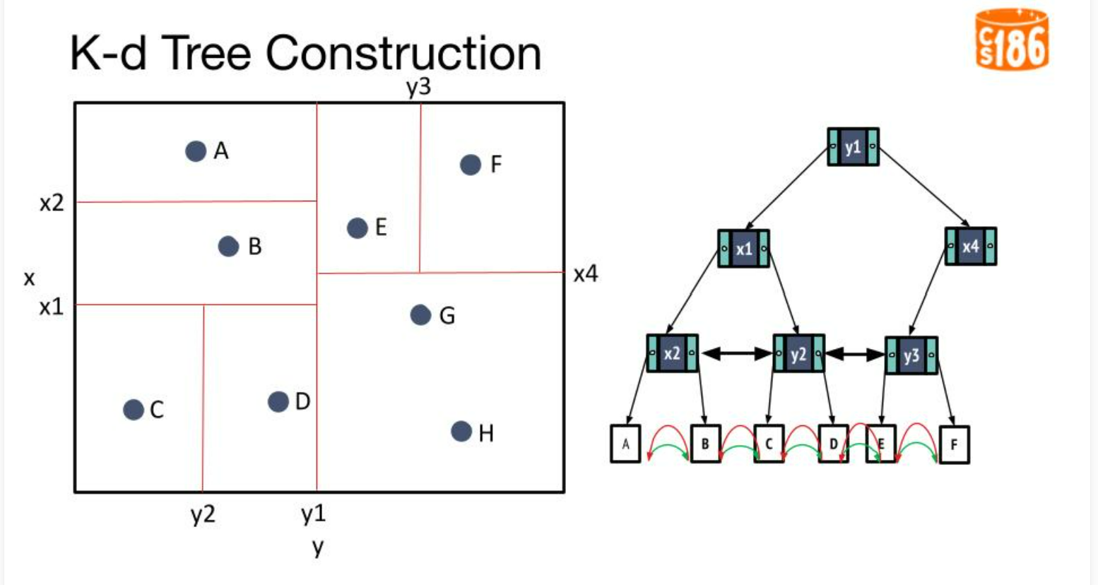
KNN | KD-Tree
Learning algorithm | Data structure
Finds nearest neighbours | Organizes points for searching
Can require many distance calculations | Can reduce search operations
Used for prediction | Supports efficient neighbour search

K-Means vs K-Means++
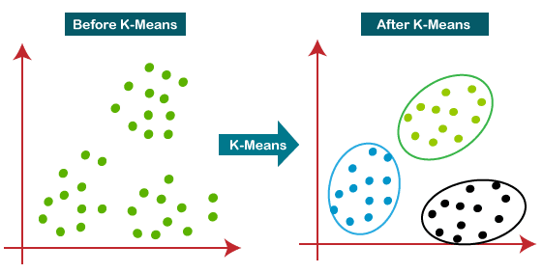

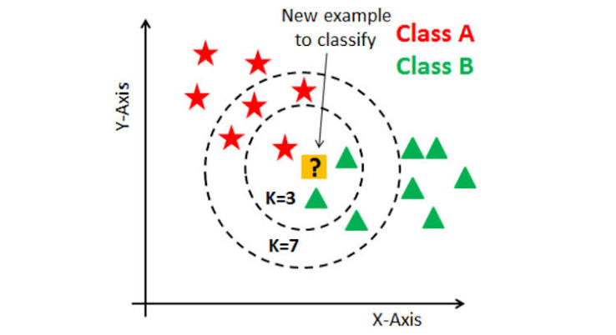
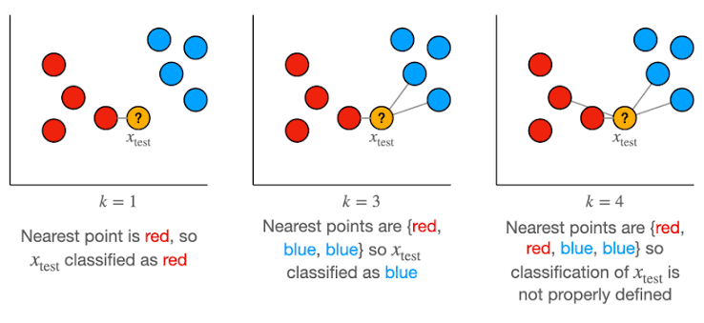
K-Means | K-Means++
Random centroid initialization | Smart centroid initialization
May produce poor starting points | Usually better starting points
Can converge to weaker solutions | Often improves clustering quality

Topic 5: Clustering with K-Means++
Clustering Concept
- Clustering is an unsupervised learning technique.
- Groups similar data points.
- Does not require predefined labels.
Example: Customer segmentation based on:
- Age
- Income
- Spending score
K-Means++ Algorithm
steps:
- Select the first centroid randomly.
- Calculate distances from existing centroids.
- Select the next centroid with probability proportional to squared distance.
- Repeat until K centroids are selected.
- Assign data points to nearest centroids.
- Update centroids and repeat until convergence.

Topic 6: Reinforcement Learning and Q-Learning
Reinforcement Learning
- Reinforcement Learning (RL) is a learning approach based on interaction with an environment.
- An agent learns through rewards and penalties.
- The goal is to maximize cumulative rewards.

Important components:
Component | Meaning
Agent | Learner or decision-maker
Environment | Surrounding system
State | Current situation
Action | Decision taken
Reward | Feedback received
Policy | Strategy for selecting actions
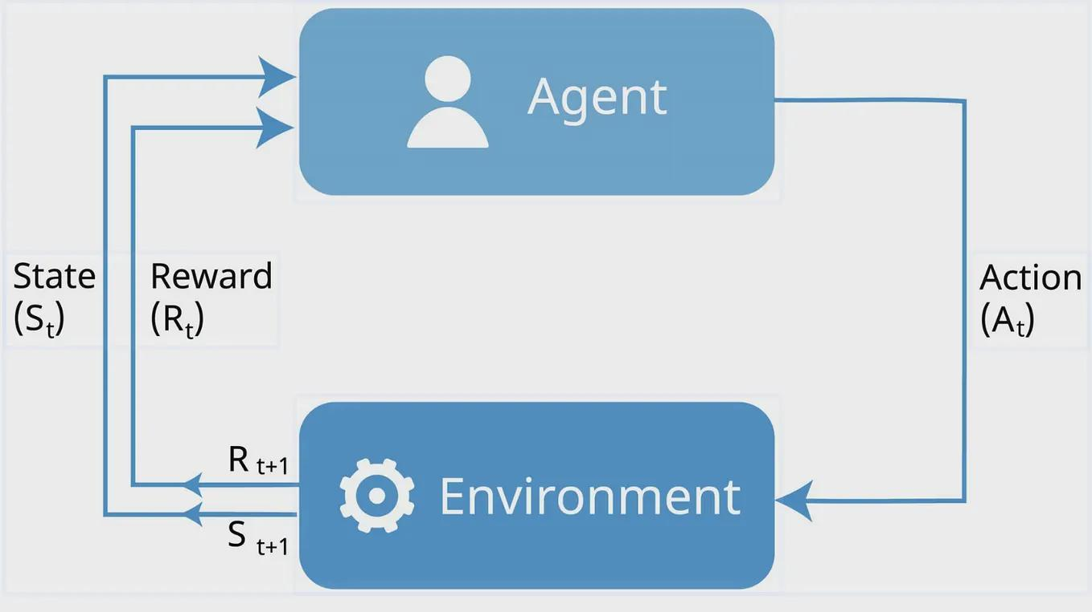

Q-Learning
Q-Learning is a model-free reinforcement learning algorithm.
It learns the value of taking an action in a particular state.
Q-value represents the expected future reward for taking an action in a state.
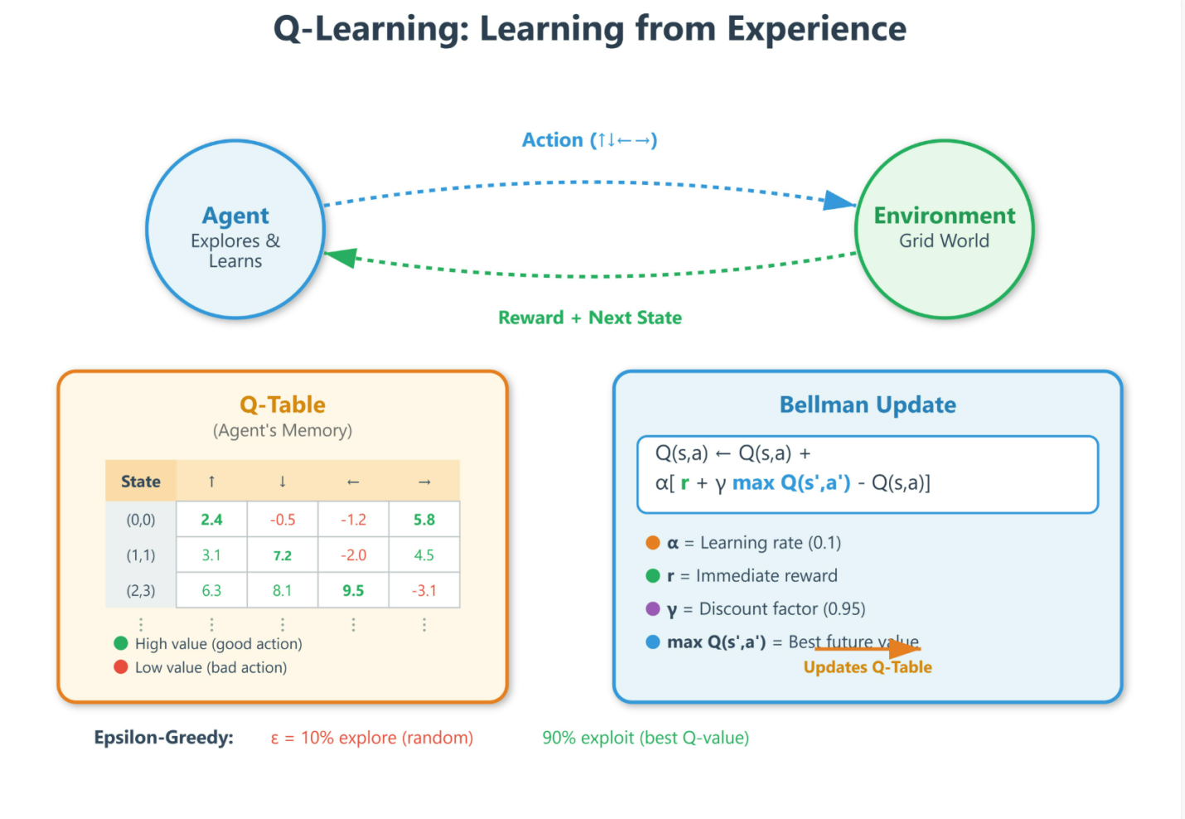
- Initialize the Q-table.
- Observe the current state.
- Select an action.
- Execute the action.
- Receive reward and next state.
- Apply the Q-Learning update formula.
- Repeat until the robot learns a good path.

